GRAPH NEURAL NETWORK ANALYSIS FOR SCALABLE FAKE PROFILE DETECTION AND BOTNETS
Conclusion, Future Scope and References
Department of Computer Science and Engineering, TKR College of Engineering & Technology
Batch A9 (CSE-A) · Academic year [ACADEMIC YEAR]
Table 1: Project team
S.No. | Student name | Roll number
1 | Bijja Naga Lakshmi | 23K91A0538
2 | Divvela Srivatshav | 23K91A0564
3 | Adumulla Durga | 23K91A0504
4 | Burugula Koushik | 23K91A0550

Project guide: Neelima
Chapter and section numbers quoted in the text (for example Chapter 8 or Section 6.2) refer to the full project report, 17.Final Document. Figures and tables in this document are numbered from 1.

1. CONCLUSION

1.1 Summary of the work
This project built BotGraph, a system that finds fake accounts and coordinated botnets from the shape of a social graph. It assembles a graph of 4,533 accounts and 94,456 ties from real Facebook ego-network topology, real labelled profile and posting rows and seeded injected botnets; describes each account with 23 features; trains a feature-only baseline and GCN, GAT and GraphSAGE models on one split; clusters suspicious accounts with Louvain over the learned embeddings; and serves scores, explanations, clusters and a moderator queue through a FastAPI backend and a React interface. The work was measured on a held-out test split, in a threshold sweep, an error analysis, a feature-group ablation and a scalability sweep, and verified with a smoke test of 36 checks.

1.2 Objectives achieved
Table 2: The six objectives of the batch against the outcome
# | Objective | Outcome
1 | Graph of accounts (nodes) and interactions (edges) | Met: 4,533 nodes, 94,456 undirected ties (88,156 real, 6,300 injected), documented schema
2 | Node features: profile, posting behaviour, interaction frequency | Met: 23 features in four groups; no text features
3 | Implement and compare GCN, GAT, GraphSAGE | Met: same split, features and budget, 3 seeds, plus a no-graph baseline; GraphSAGE best (F1 0.939)
4 | Detect botnet clusters from embeddings | Met on injected botnets: 8 of 8 recovered; real botnets not tested
5 | Evaluate accuracy, precision, recall | Met: six metrics, ROC and PR curves, confusion matrices, threshold sweep; labels are partly synthetic
6 | Assess scalability | Met up to 36,264 accounts and 755,648 ties on CPU, roughly linear; platform scale not tested

1.3 Key findings
1. The graph helps, but not every architecture equally. On the 908-account test split GraphSAGE reaches F1 0.939 ± 0.006 (precision 0.975, recall 0.906, ROC-AUC 0.990) against 0.827 ± 0.010 for the no-graph baseline, a gain of 11.2 points. GAT gains 7.3 points and GCN only 1.0, with a recall (0.743) below the baseline's (0.789). In the seed-0 confusion matrix GraphSAGE makes 3 false positives and 9 false negatives among 908 accounts.
2. The result does not hinge on the threshold. F1 stays between 0.927 and 0.952 for every threshold from 0.30 to 0.60; the tuned threshold of 0.5 gave precision 0.972 and recall 0.921 at seed 0.
3. Botnets are found, lone spammers less so. All 82 botnet members in the test split were caught (the baseline 64), but only 23 of 32 lone spammers (the baseline 26); the graph rescued 18 fake accounts the baseline missed, lost 3 and left 6 missed by both. Louvain over the embeddings recovered 8 of 8 injected botnets as single communities (mean recall 1.000, mean precision 0.988).
4. The benchmark is structurally easy, and this limits what the headline number means. GraphSAGE on node degree alone scores F1 0.965, above the model with all features (0.942); the synthetic temporal group is the most valuable attribute group (removing it lowers GraphSAGE to 0.840 and the baseline to 0.515), and posting behaviour adds nothing. The high scores describe this benchmark with injected botnets, not a real platform.
5. Cost grows roughly in proportion to the number of ties. From 4,533 to 36,264 accounts a GraphSAGE epoch took 0.060 s and then 0.392 s; GAT took 0.255 s and then 2.022 s. GraphSAGE is both the most accurate and the cheapest graph model here.
6. The application behaves as specified. The smoke test passes 36 of 36 checks, API reads take a median of 3 to 16 ms, and the moderator loop records decisions, retrains and logs F1 before and after without touching the test split.
7. Against the base paper. PruferNET [1] classifies nodes by spanning-tree depth and reports 99.63% accuracy; BotGraph detects fake accounts on a partly synthetic imbalanced graph. The tasks, labels and data differ, so the numbers are not compared; the shared finding is that structural information improves a GraphSAGE node classifier.

1.4 Practical applications
• Trust-and-safety triage. A ranked queue of flagged accounts with reasons and neighbourhood, in place of a flat list of reports.
• Coordinated-behaviour review. A moderator can act on a whole botnet in one decision after inspecting its shared peak hour, creation spread and tie density.
• Model selection for graph-based moderation tools. The comparison with a no-graph control shows how much a graph model is worth before its cost is accepted.
• Teaching and research. The code is a compact, readable reference implementation of three GNN layers, community detection and a human-in-the-loop workflow.

1.5 Known limitations
The injected botnets are densely tied and share timing, so cluster recovery and the graph's lift are measured on an easy case (degree alone gives F1 0.965); half of the attribute signal is synthetic; text features, temporal graphs and real labelled botnets are absent; evaluation uses one split and three seeds; scalability was tested to 36 k accounts with copies of the graph; and security is for a demonstration. Chapter 10 turns each into future work.
The results behind the key findings are shown below: how the three graph models compare with the no-graph baseline, and how the botnet clusters match the injected botnets.
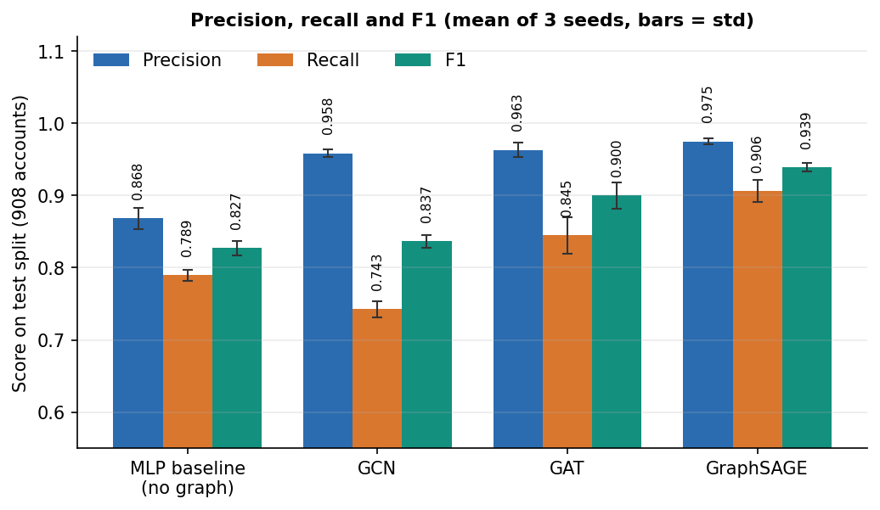
Figure 1: Precision, recall and F1 of the baseline and the three graph models on the 908-account test split (mean and standard deviation over 3 seeds).
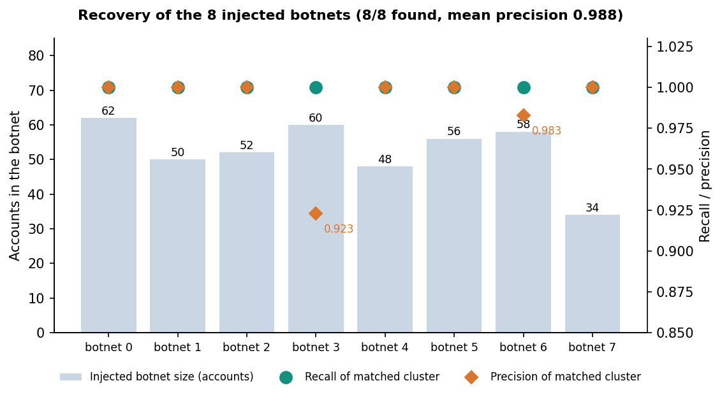
Figure 2: Recovery of the eight injected botnets: size, recall and precision of the community matched to each.

2. FUTURE SCOPE

2.1 Improvements to the models and the evidence
1. Harder, less structurally distinctive botnets. The degree-only result (0.965) shows that the injected botnets are easy. A next benchmark should vary botnet density, mix bots into the real community structure, use bots with ordinary degree and add bots that imitate real neighbourhoods.
2. Real labelled botnets. Evaluate on public bot-detection benchmarks with real accounts and labels (for example TwiBot-20 and TwiBot-22 [19], [21]) to replace the known-answer test with real-world evidence.
3. Structural features from the base paper. Add Prüfer-sequence, closeness, PageRank and trust features [1] to the node features and measure their value with the ablation already built, now that node degree is known to carry so much.
4. Text and behavioural NLP. Add features from post text and language-model embeddings, as the batch abstract proposed and as LGB [4] does for sparsely connected accounts, which would address the lone spammers that the graph does not catch.
5. Imbalance and noise handling. Compare the class-weighted loss with graph augmentation and edge filtering in the style of RABot [2] and with homophily-aware filtering as in HW-GNN [3].
6. Temporal graphs. Replace the one-snapshot graph with a sequence of snapshots or a dynamic graph model [5], [6] so that bots can be found by how their ties and activity change.
7. Rigorous evaluation. Repeated stratified cross-validation, confidence intervals, significance tests between architectures, and a held-out set of accounts that were never in the graph (inductive evaluation).

2.2 Additional features
• Pairwise and group evidence in the queue: why two accounts are in one cluster, with the shared traits highlighted.
• Active learning: ask moderators about the accounts whose decisions would change the model most.
• Appeals and decision review by a second moderator; decision statistics per moderator.
• Export of confirmed accounts and clusters, and a feed of new flags.
• Alerts when a new cluster appears between two scoring runs.

2.3 Scalability and deployment
• Neighbour sampling and mini-batch training (as in GraphSAGE's original design [10]), and a GPU path, so that graphs of millions of accounts fit in memory; measure on a real, well-mixed graph rather than copies.
• Incremental scoring of new accounts and ties without retraining the whole model.
• A pytest suite for the ML and API layers, a load test with many concurrent users, and a continuous-integration run of the smoke test.
• A production database (PostgreSQL), containerised deployment, TLS, single sign-on with multi-factor authentication, rate limiting, token revocation and an audit log.
• Monitoring for drift in score distributions and in the share of flagged accounts, with a scheduled retraining policy.

2.4 Further research
• Robustness to adaptive bots that add ties to genuine accounts or copy profiles, and defences such as edge filtering.
• Explanations that are faithful rather than first-order: integrated gradients or subgraph explainers, compared with the gradient × input bars used here.
• Joint learning of classification and clustering, so that the embeddings are trained to separate botnets directly.
• Fairness and privacy: whether regional or language communities are flagged more often, and how to review accounts without exposing private content.
• A study with real moderators of whether the queue and the explanations speed up decisions and reduce errors.

2.5 Priority of the future work
Table 3: Suggested order of future work
# | Item | Effort | Why it matters
1 | Harder benchmark and real labelled botnets | Medium to large | Replaces the known-answer test with evidence that survives outside the generator
2 | Text features and the base paper's structural features | Medium | Targets the lone spammers the graph misses
3 | Cross-validation, intervals, inductive evaluation | Small | Shows how much of the gap between models is noise
4 | Neighbour sampling, GPU, real large graph | Medium to large | Tests the scalability claim where it matters
5 | Authentication hardening, TLS, tests and deployment | Medium | Moves the demonstration towards a service
6 | Adversarial testing | Large | Shows whether the detector survives bots that adapt

3. REFERENCES
[1] A. Saha, N. K. Sarkar and S. Pratihar, "PruferNET: An augmented graph neural network for influential node detection in social networks," IEEE Access, vol. 14, pp. 79940-79959, 2026, doi: 10.1109/ACCESS.2026.3695637.
[2] L. Zhang, X. Wang, H. Du, Y. Xu, Z. Liu and Y. Liu, "RABot: Reinforcement-guided graph augmentation for imbalanced and noisy social bot detection," arXiv:2602.21749, Feb. 2026.
[3] Z. Liu, J. Gao, Z. Ji and L. Zhao, "HW-GNN: Homophily-aware Gaussian-window constrained graph spectral network for social network bot detection," arXiv:2511.22493, Nov. 2025.
[4] M. Zhou, D. Zhang, Y. Wang, Y. Geng, Y. Dong and J. Tang, "LGB: Language model and graph neural network-driven social bot detection," arXiv:2406.08762, Jun. 2024.
[5] B. He, Y. Yang, Q. Wu, H. Liu, R. Yang, H. Peng, X. Wang, Y. Liao and P. Zhou, "BotDGT: Dynamicity-aware social bot detection with dynamic graph transformers," arXiv:2404.15070, Apr. 2024 (IJCAI 2024 per the arXiv record).
[6] W. Wang, T. Zang and X. Zhang, "Temporal-aware social bot detection with graph contrastive learning," in Computational Science - ICCS 2025, Springer, 2025.
[7] S. Shi, K. Qiao, Z. Wang, J. Yang, B. Song, J. Chen and B. Yan, "Multi-scale graph neural network with signed-attention for social bot detection: A frequency perspective," arXiv:2307.01968, Jul. 2023.
[8] T. N. Kipf and M. Welling, "Semi-supervised classification with graph convolutional networks," in Proc. Int. Conf. Learn. Represent. (ICLR), 2017, arXiv:1609.02907.
[9] P. Velickovic, G. Cucurull, A. Casanova, A. Romero, P. Lio and Y. Bengio, "Graph attention networks," in Proc. Int. Conf. Learn. Represent. (ICLR), 2018, arXiv:1710.10903.
[10] W. L. Hamilton, R. Ying and J. Leskovec, "Inductive representation learning on large graphs," in Advances in Neural Information Processing Systems (NeurIPS), vol. 30, 2017, pp. 1024-1034.
[11] V. D. Blondel, J.-L. Guillaume, R. Lambiotte and E. Lefebvre, "Fast unfolding of communities in large networks," J. Stat. Mech.: Theory Exp., no. 10, p. P10008, 2008.
[12] J. McAuley and J. Leskovec, "Learning to discover social circles in ego networks," in Advances in Neural Information Processing Systems (NeurIPS), vol. 25, 2012, pp. 539-547.
[13] D. P. Kingma and J. Ba, "Adam: A method for stochastic optimization," in Proc. Int. Conf. Learn. Represent. (ICLR), 2015, arXiv:1412.6980.
[14] A. Paszke et al., "PyTorch: An imperative style, high-performance deep learning library," in Advances in Neural Information Processing Systems (NeurIPS), vol. 32, 2019, arXiv:1912.01703.
[15] F. Pedregosa et al., "Scikit-learn: Machine learning in Python," J. Mach. Learn. Res., vol. 12, pp. 2825-2830, 2011.
[16] A. A. Hagberg, D. A. Schult and P. J. Swart, "Exploring network structure, dynamics, and function using NetworkX," in Proc. 7th Python in Science Conf. (SciPy), 2008, pp. 11-15.
[17] S. Cresci, "A decade of social bot detection," Commun. ACM, vol. 63, no. 10, pp. 72-83, Oct. 2020.
[18] E. Ferrara, O. Varol, C. Davis, F. Menczer and A. Flammini, "The rise of social bots," Commun. ACM, vol. 59, no. 7, pp. 96-104, Jul. 2016.
[19] S. Feng, H. Wan, N. Wang, J. Li and M. Luo, "TwiBot-20: A comprehensive Twitter bot detection benchmark," in Proc. 30th ACM Int. Conf. Inf. Knowl. Manag. (CIKM), 2021, pp. 4485-4494.
[20] S. Feng, H. Wan, N. Wang and M. Luo, "BotRGCN: Twitter bot detection with relational graph convolutional networks," in Proc. IEEE/ACM Int. Conf. Adv. Soc. Netw. Anal. Min. (ASONAM), 2021, pp. 236-239.
[21] S. Feng et al., "TwiBot-22: Towards graph-based Twitter bot detection," in Advances in Neural Information Processing Systems (NeurIPS), Datasets and Benchmarks Track, vol. 35, 2022.
[22] H. Prüfer, "Neuer Beweis eines Satzes über Permutationen," Arch. Math. Phys., vol. 27, pp. 142-144, 1918.
[23] N. Srivastava, G. Hinton, A. Krizhevsky, I. Sutskever and R. Salakhutdinov, "Dropout: A simple way to prevent neural networks from overfitting," J. Mach. Learn. Res., vol. 15, pp. 1929-1958, 2014.
[24] D.-A. Clevert, T. Unterthiner and S. Hochreiter, "Fast and accurate deep network learning by exponential linear units (ELUs)," in Proc. Int. Conf. Learn. Represent. (ICLR), 2016, arXiv:1511.07289.
[25] A. Shrikumar, P. Greenside, A. Shcherbina and A. Kundaje, "Not just a black box: Learning important features through propagating activation differences," arXiv:1605.01713, 2016.
[26] N. V. Chawla, K. W. Bowyer, L. O. Hall and W. P. Kegelmeyer, "SMOTE: Synthetic minority over-sampling technique," J. Artif. Intell. Res., vol. 16, pp. 321-357, 2002.
[27] S. Ramírez, "FastAPI," software framework, https://fastapi.tiangolo.com (accessed Oct. 2026).
[28] M. Bayer, "SQLAlchemy," in The Architecture of Open Source Applications, Volume II, A. Brown and G. Wilson, Eds. 2012.
[29] M. Jones, J. Bradley and N. Sakimura, "JSON Web Token (JWT)," IETF RFC 7519, May 2015.
[30] N. Provos and D. Mazières, "A future-adaptable password scheme," in Proc. USENIX Annu. Tech. Conf., FREENIX Track, 1999, pp. 81-91.
[31] free4ever1, "Instagram fake spammer genuine accounts," Kaggle dataset, licence CC BY 3.0, https://www.kaggle.com/datasets/free4ever1/instagram-fake-spammer-genuine-accounts (accessed Oct. 2026).
[32] goyaladi, "Twitter bot detection dataset," Kaggle dataset, licence CC0, https://www.kaggle.com/datasets/goyaladi/twitter-bot-detection-dataset (accessed Oct. 2026).
[33] J. Sharma and S. Borah, "Stacking of machine learning classifiers for bot detection using account level data," Int. J. Informatics Commun. Technol. (IJ-ICT), vol. 15, no. 2, pp. 477-487, Jun. 2026, doi: 10.11591/ijict.v15i2.pp477-487 (nearest match to batch survey item 4; the batch title could not be found).
[34] "AdapTGN: An adaptive temporal-relational graph neural network for social media bot detection," 2026 (listed in the batch survey; not independently verified).
[35] "A novel graph neural network approach for social network fake news identification in Arabic," in Proc. 18th Int. Conf. Agents Artif. Intell., 2026 (listed in the batch survey; not independently verified).
[36] "Social media bot detection using account metadata, advanced feature selection, and stacking," Int. J. Sci. Res. (IJSR), 2026 (listed in the batch survey; not independently verified; see [33] for the nearest match found).

